Atomic scale simulation-HW3 Jinsheng Wang (NetID: jwang278) 9/29/16

**The parameters used:**

temperature: 0.728

box length: 4.2323167

number of particles: 64

time step size: 0.01

number of time steps: 1000

**Instantaneous temperature**

Plot of instantaneous temperature

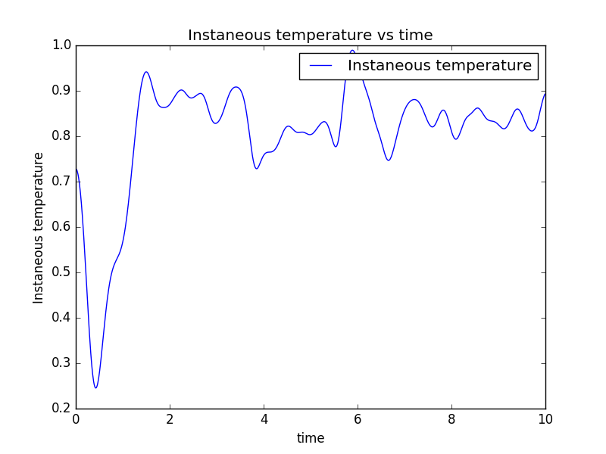

plot of energy

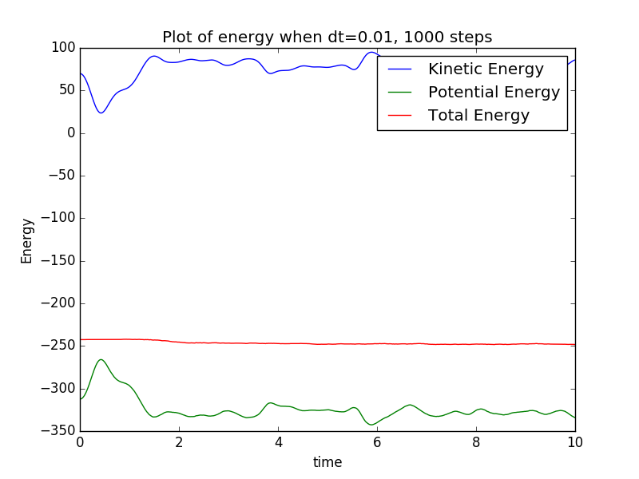

comment: from the above two pictures, it can be easily seen that the trend of instantaneous temperature agrees with that of the kinetic energy. In principle, they are interchangeable just with a coefficient.

**Momentum**

Momentum is a vector value, not a scalar value, so we have to compare all three direction of the momentum to determine if it is conserved or not.

Here is the plot of momentum of all 3 directions.

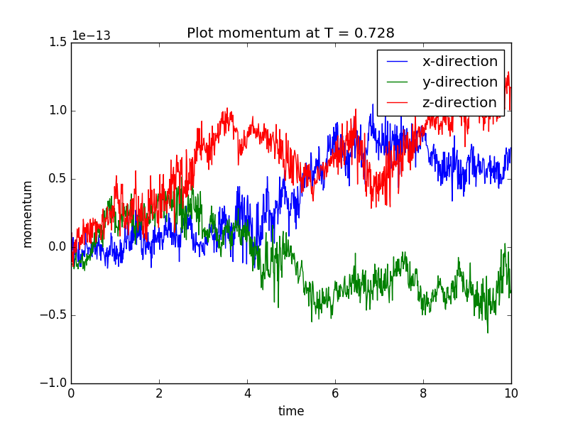

comment: it can be seen that the variation of momentum is on the order of 10^-13, which means the momentum is conserved. Since the system is not interacting with the outside, there is no external force on the simulation box, according to momentum conservation law, even before calculation we already know it to be conserved for sure.

**Pair correlation function**

Plot of pair correlation cut the r range into 50 bins from 0 to half of box length, namely, cutoff.

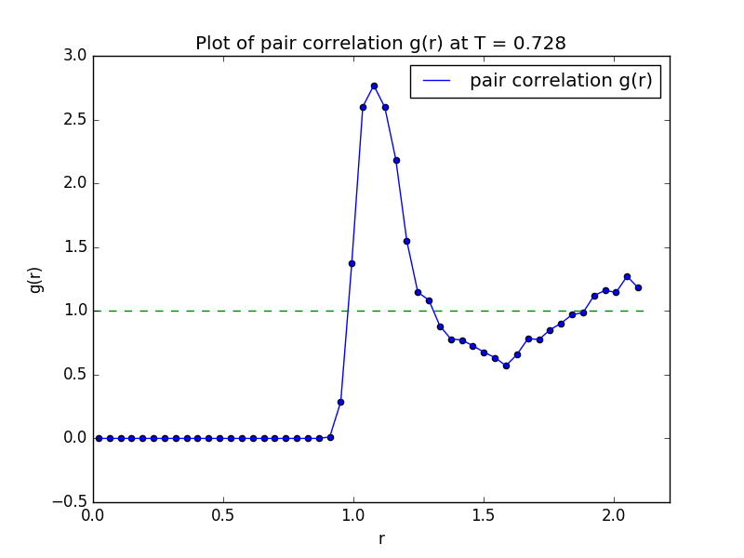

comment: this plot is average over the last 500/1000 steps of the simulation to ensure the system is well equilibrated. The curve may seem not very smooth, and different dr values can be used of course. The overall trend of the plot is not hard to recognized. It can be seen at large r the g(r) tend to converge to 1.

**Structure factor**

Plot of structure factor S(k).

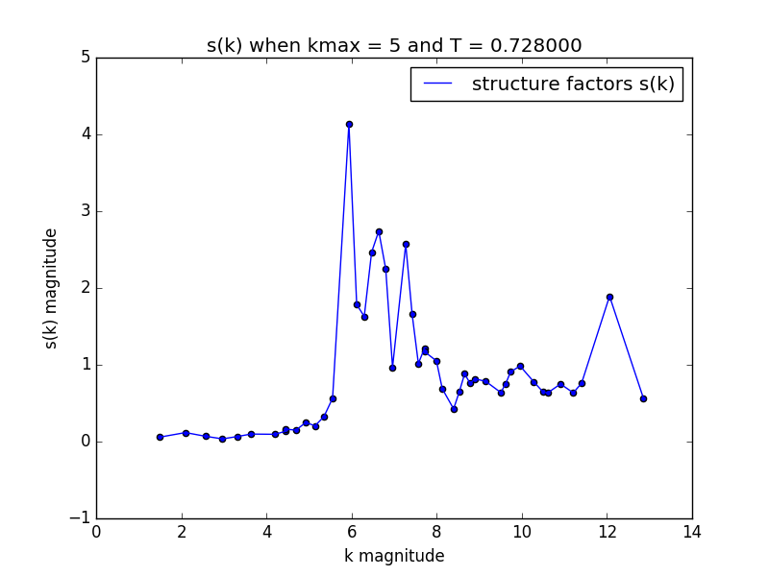

Question: Describe qualitatively how S(k) and g(r) should look like for a liquid and a solid.

Answer: For solid, the atoms are well arranged together, corresponding to sharp peaks both in the pair correlation and structure factors profiles. For liquid, the atoms tend to be less bonded and arranged in space, so there will not be very sharp peaks in the two profiles.

**Velocity-velocity correlation and Diffusion constant**

Plot of v-v correlation vs time

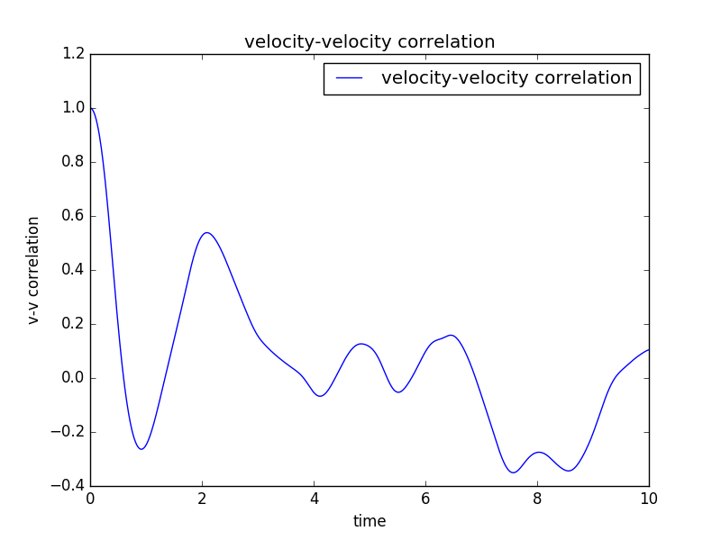

At the beginning, the v-v correlation is 1 due to normalization, but drops which means the system lost some of its memory of initial state very quickly. Later the correlation will fluctuate around 0. During this process, if we calculate the diffusion constant:



Diffusion constant D = 0.457997

now, if we use Green-Kubo relation as below:

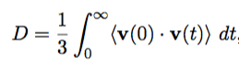

then we get the answer as:

Diffusion constant D = 0.152666

**Andersen Thermostat**

Plot of instantaneous temperature when collision possibility is 0.01, and temperature of heat bath is also 0.728

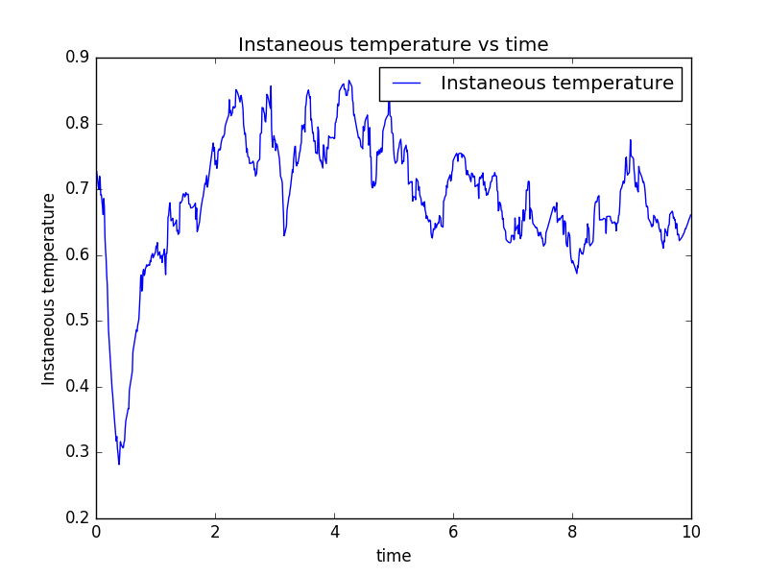

Plot of instantaneous temperature when collision possibility is 0.01, and temperature of heat bath is 1.0

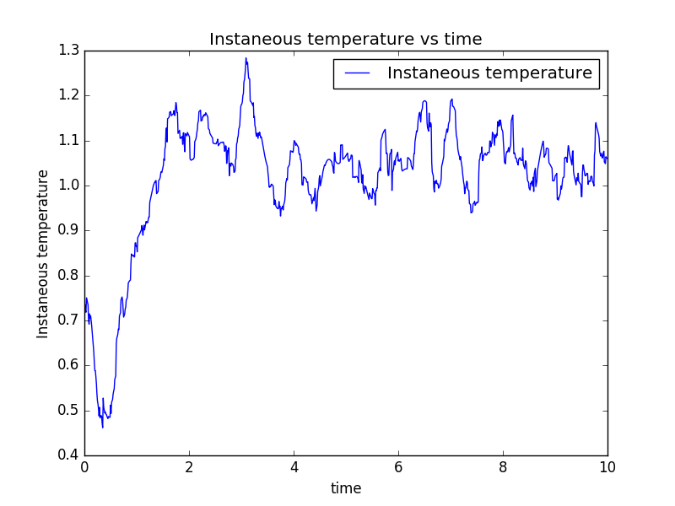

Now change collision possibility to 0.5 and heat bath temperature is also 0.728. plot v-v correlation and calculate diffusion constant

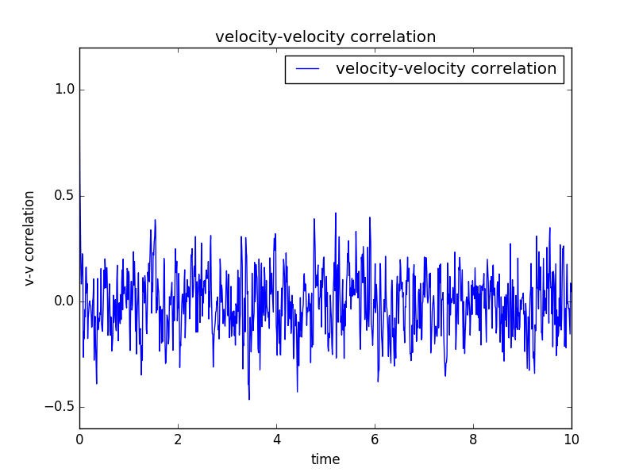

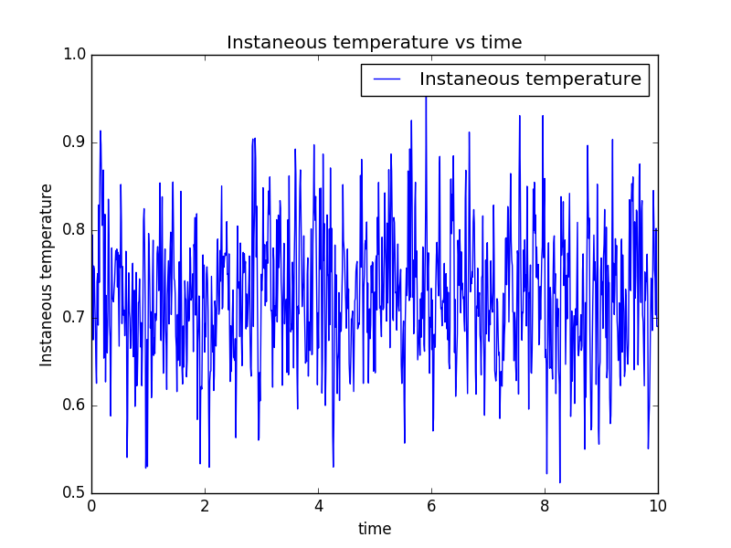

Diffusion constant D = -0.066450

Green-Kubo Diffusion constant D = -0.02215

**Compare microcanonical simulation and Anderson thermostat:**

Before the comparison, I expect to see that the diffusion constant of microcanonical ensemble is larger than the Anderson thermostat. Because before reaching thermo equilibrium, the microcanonical simulation is determined by Newton law, which means the next step velocity has a strong correlation with the previous step, causing larger diffusion constant. But for Anderson thermostat, the velocity is strongly randomly sampled from the Normal distribution, which means next steps velocity has nothing to do with the previous step. In a word, microcanonical ensemble has some memory while Anderson thermostat has none. In fact, this is found to be true from the figures and D values above.

**Calculating phase transitions**

Use Anderson thermosat with collision possibility as 0.01, set initial and heat bath shares the same temperature as follows. First choose temperature as 0.8, 1.6, 2.4, 3.2, 4.0 and give the plots of pair correlation and structure factors as below.

Pair correlation g(r) and structure factors S(k) for different temperatures.

* T=0.8

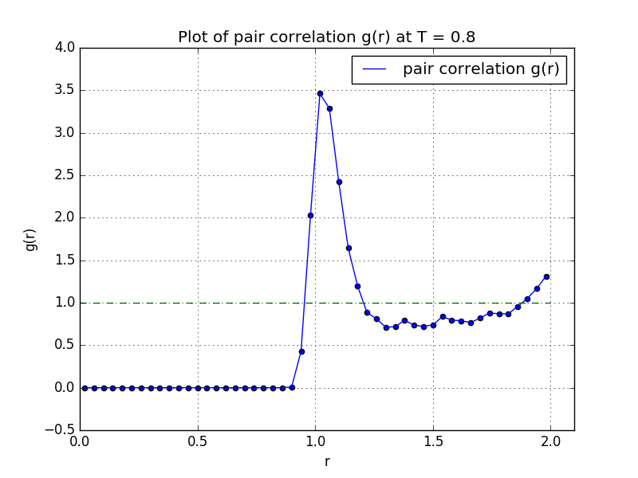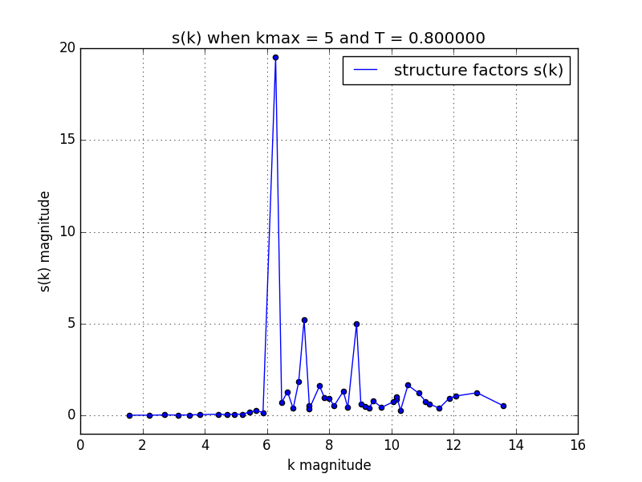

* T=1.6

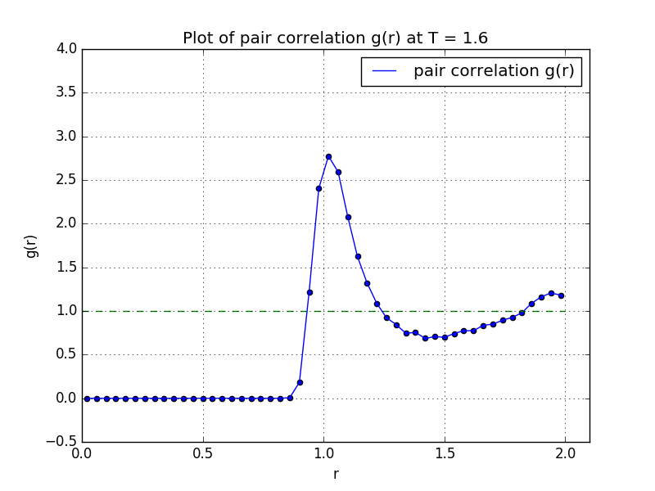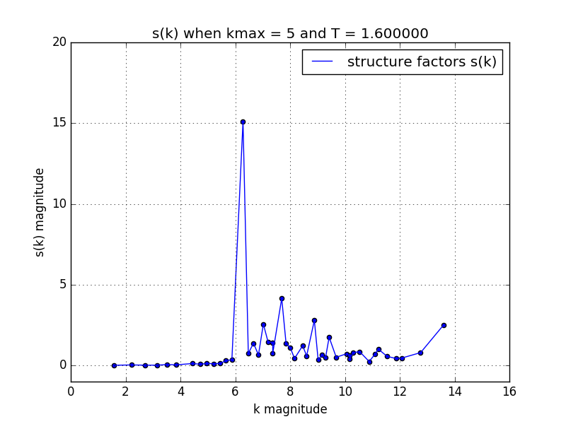

* T=2.4

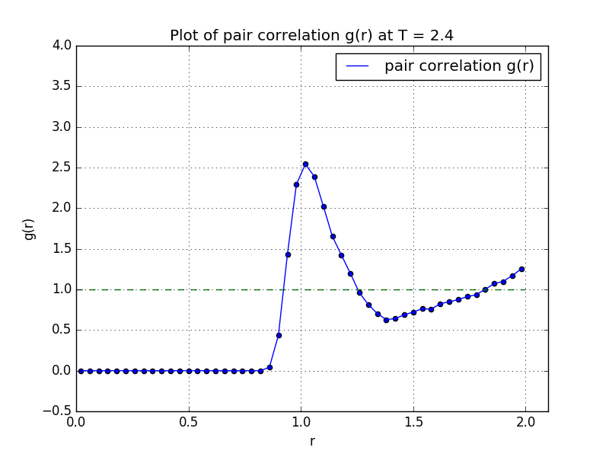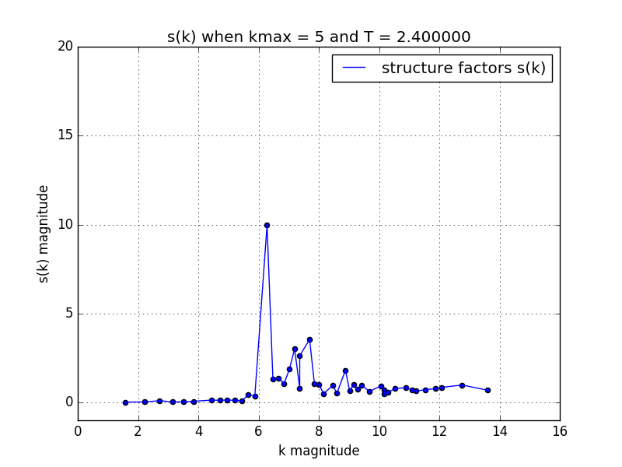

* T=3.2

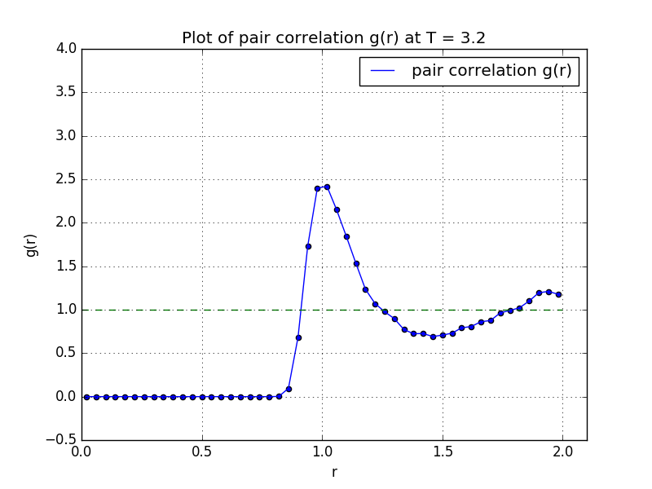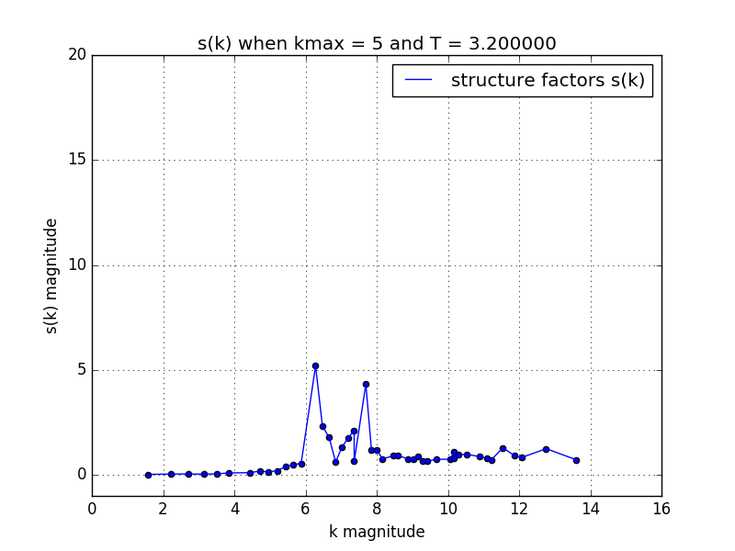

* T=4.0

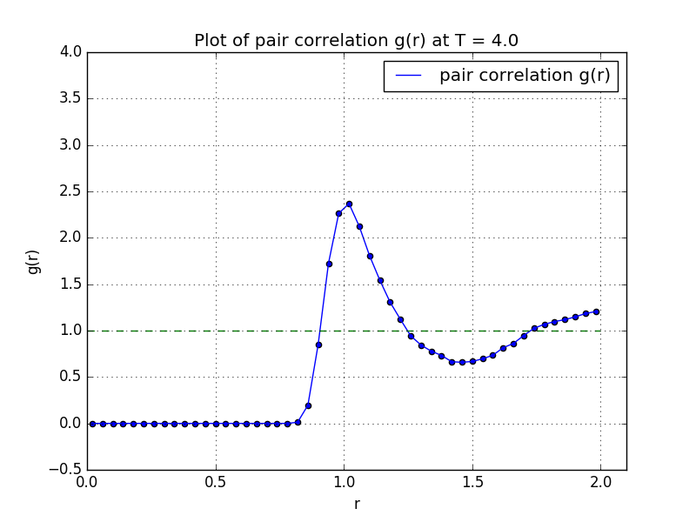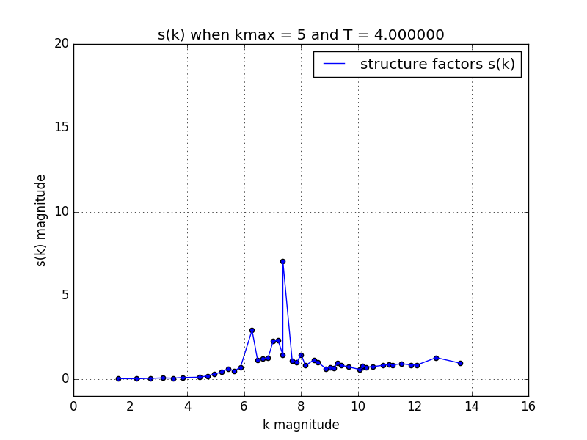

Now, we add 3 temperature values, 1.8, 2.0, 2.2, 2.3.

* T=1.8

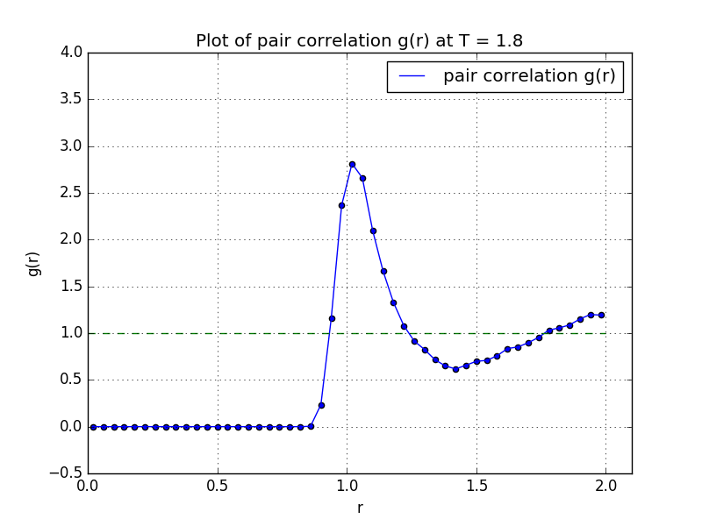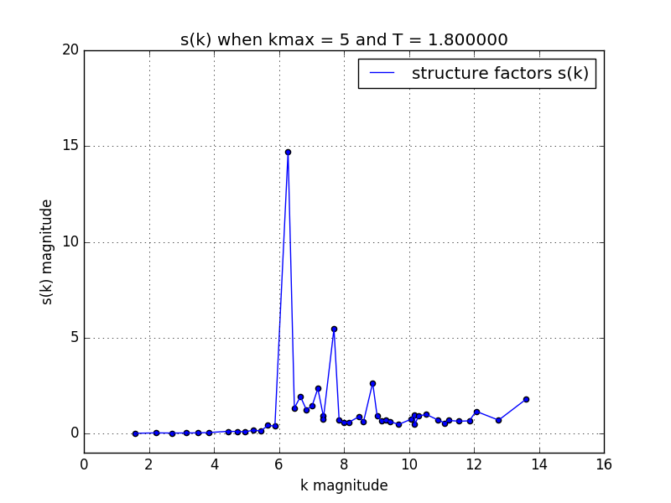

* T=2.0

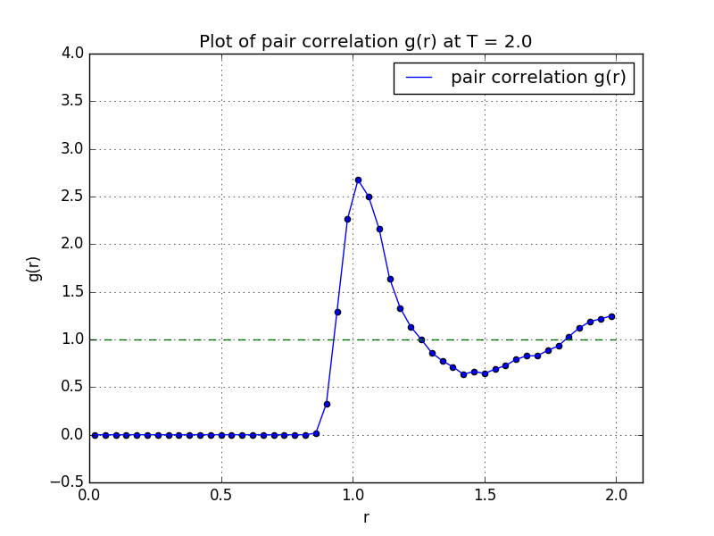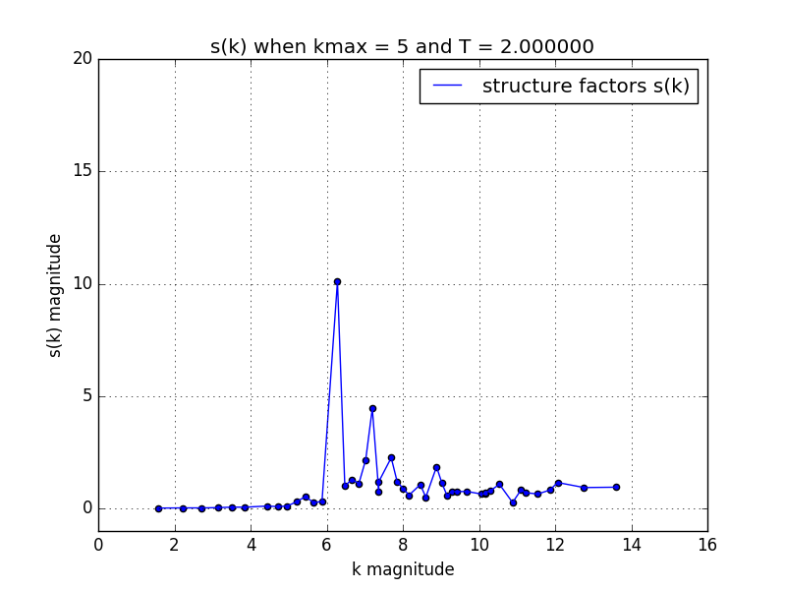

* T=2.2

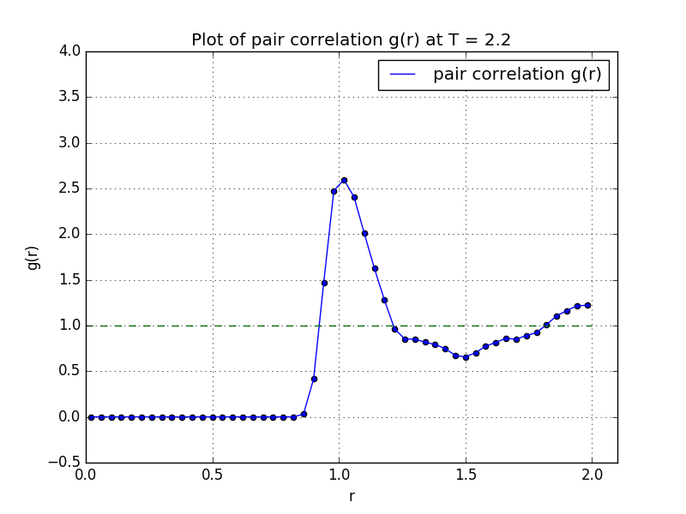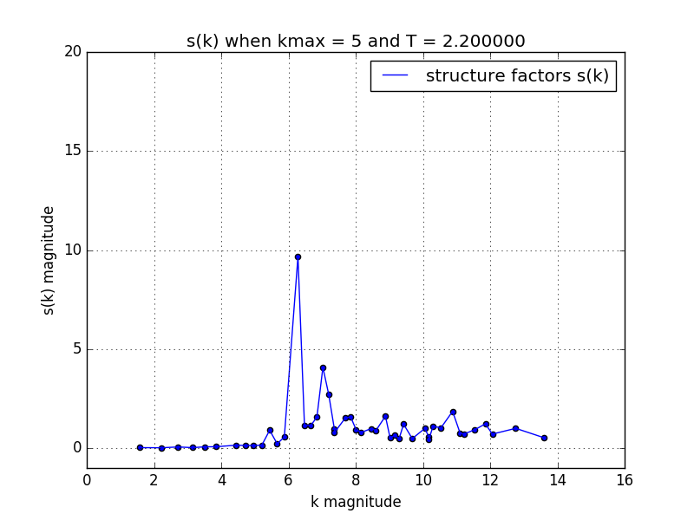

* T=2.3

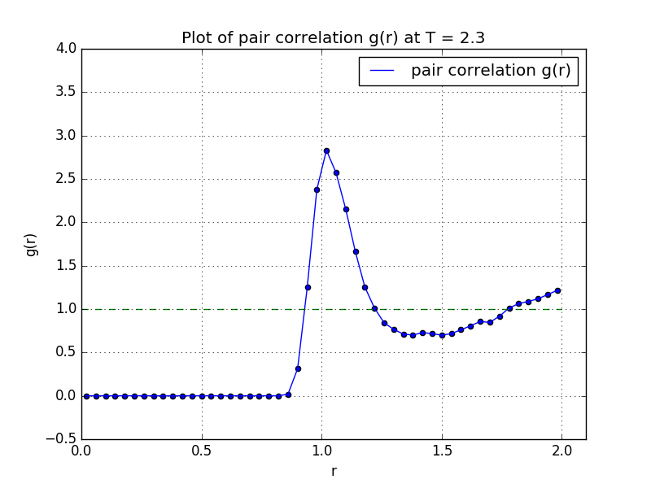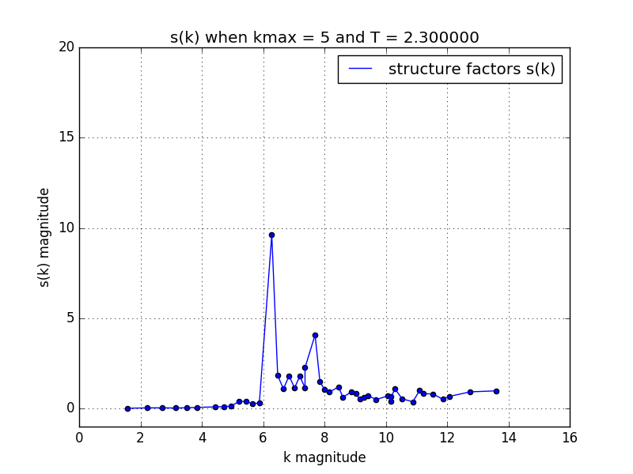

now, plot the peak intensity of all the structures as below:

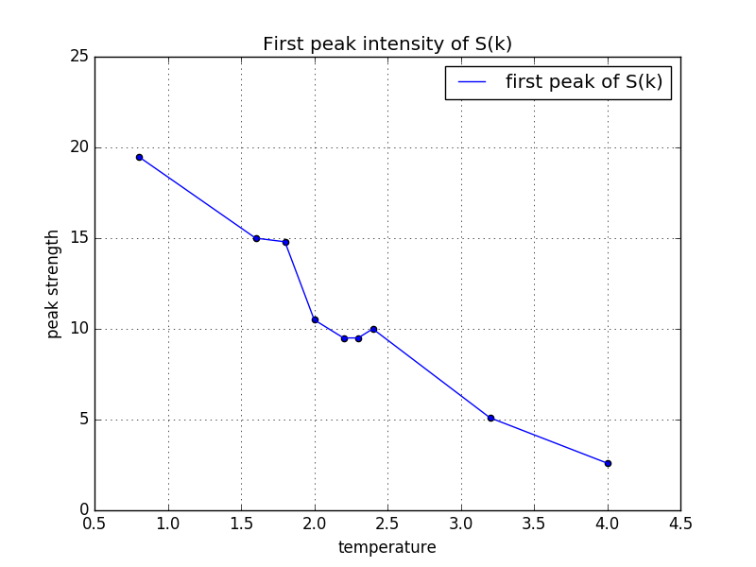

Conclusion, from the structure factors variation trend and first peak intensity variation trend, we can roughly guess that the solid – liquid transition temperature is about 2.0.